Here is a screenshot of the 18 (out of 23) files that downloaded…
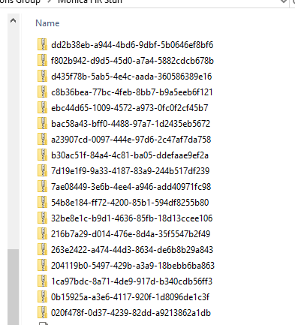

I re-logged in to WinSCP – however – when I opened the ADP folder, there was only one zip file showing. I tried to download it and at first it looked like all was going well but it did not go through. When I tried to select download again, here is the message box I see. Not sure what happened to the rest of the zip files. Can you tell?

